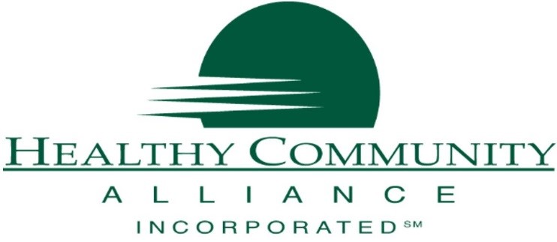
Upstate Community Based Organization (CBO) Consortium Engagement Form
Agreement
As a community-based organization (CBO) engaged in the CBO Planning Grant through the New York State Department of Health, I certify that my organization, as of (Date),
- Does not bill Medicaid,
- Has an operating budget less than $5 million
- Is a non-profit 501c3
- Has been addressing a social determinant(s) of health for more than 2 years, and
- Serves the following counties in New York State:

Furthermore, I understand that I am expected to participate in technical assistance sessions (webinars) and regular meetings (via webinar/conference call) during the grant period of 12/01/2018 to 11/30/2019.
For participating, my organization will be reimbursed an all-inclusive rate of $100 per hour for participation in meetings and webinars. As part of that all-inclusive rate, I will also be expected to complete surveys and respond to emails.

Printed Name

Signature

Organization

Date

Community Based Organization Contact Form

Name of Organization:
Address of Organization:
Primary county in which you operate:
Organization Tax ID:
Contact Name:
Contact Email:
Contact Phone:
Contact Fax:
Annual Organization Budget:
Years Servicing your Community:
Does your organization bill Medicaid? Yes ☐ No ☐
How many people does your organization serve annually?
What social determinants of health does your organization address? (Check all that apply)
Economic  Stability | Poverty | ☐
 | Housing Security & Stability | ☐
 | Employment | ☐
 | Food Security | ☐
 | Transportation | ☐
Education | Early Childhood Education and Development | ☐
 | High School Education | ☐
 | Enrollment in Higher Education | ☐
 | Language and Literacy | ☐
Social, Family  & Community | Social Cohesion | ☐
 | Civic Participation | ☐
 | Perceptions of Discrimination and Equity | ☐
 | Incarceration/Institutionalization | ☐
Neighborhood  & Environment | Affordable/Quality Housing | ☐
 | Environmental Conditions | ☐
 | Access to Health Foods | ☐
 | Crime and Violence | ☐
Health &  Health Care | Access to Healthcare- gaining entry into HC System | ☐
 | Access to Primary Care/Trusted Provider | ☐
 | Health Literacy | ☐

Other: List services you provide that do not fit into the check off list above.

Click or tap here to enter text.

