Health Care Victory & Anniversary Celebration
Fri. Aug. 4, 11 a.m.

at NY State Nurses Association, 131 W. 33rd St., 2nd fl., in Manhattan

Guest speakers to be announced. Cake and refreshments!

What’s to Celebrate?

- After 6 months of intense work, grassroots activists beat back efforts in Congress to gut the Affordable Care Act, decimate Medicaid, and defund Planned Parenthood.

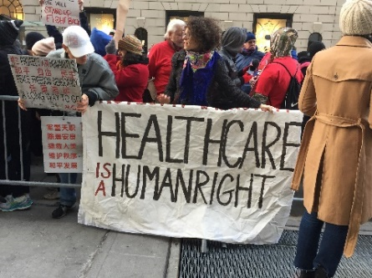

- 52 years ago on July 30, President Johnson signed the law creating Medicare and Medicaid, programs that have benefitted tens of millions of Americans and families.

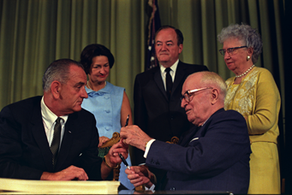

- 20 years ago on August 5, President Clinton signed the law creating the State Child Health Insurance Program (SCHIP) that has benefited millions of uninsured children.

Sponsors [list in formation]: Center for Independence of the Disabled-NY, Children’s Defense Fund-NY, Health Care for All NY, Health Care for America Now-NYC, Medicaid Matters NY, Medicare Rights Center, Metro NY Health Care for All, NYS Alliance for Retired Americans, NY Statewide Senior Action Council

RSVPs please! (…so we have enough cake!):
https://actionnetwork.org/events/health-care-victory-and-anniversary-celebration

