To: NYS Congressional Delegation
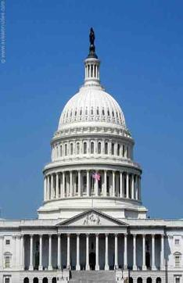

Opposing Federal Budget Cuts to Medicare
The House Budget ends the Medicare program as we know it. It proposes privatizing Medicare by replacing Medicare’s guaranteed health benefits with a voucher (or premium support) that seniors and people with disabilities would use to purchase health coverage through private health care plans. The privatization idea reduces the security of traditional Medicare, funneling younger and healthier retirees into private health plans and leaving older, sick beneficiaries in the traditional Medicare program. Providing coverage for this vulnerable population will make traditional Medicare more expensive and less able to compete. The proposed House Budget would force seniors and people with disabilities to pay more for less by raising the Medicare eligibility age and increasing premiums for the middle class.
Congress must reject this plan and instead look to responsible options, like securing lower prices for prescription drugs, to secure Medicare’s future for years to come.
PRINT NAME PRINT ADDRESS
____________________________________________________________________________________________________________________________________________________________________________________________________________________________________________________________________________________________________________________________________________________________________________________________________________________________________________________________________________________________________________________________________________________________________________________________________________
____________________________________________________________________________________________________________________________________________________________________________________________________________________________________________________________________________________________________________________________________________________________________________________________________________________________________________________________________________________________________________________________________________________________________________________________________________

PRINT NAME PRINT ADDRESS
____________________________________________________________________________________________________________________________________________________________________________________________________________________________________________________________________________________________________________________________________________________________________________________________________________________________________________________________________________________________________________________________________________________________________________________________________________
____________________________________________________________________________________________________________________________________________________________________________________________________________________________________________________________________________________________________________________________________________________________________________________________________________________________________________________________________________________________________________________________________________________________________________________________________________
____________________________________________________________________________________________________________________________________________________________________________________________________________________________________________________________________________________________________________________________________________________________________________________________________________________________________________________________________________________________________________________________________________________________________________________________________________
____________________________________________________________________________________________________________________________________________________________________________________________________

