To: NYS Congressional Delegation
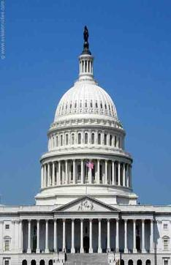

Strengthening Social Security Act HR 3118 / S 567
The undersigned urge Congress to pass legislation that would increase Social Security benefits to provide a livable retirement for millions of Americans and their families, today and tomorrow.
Social Security is the major source of income for most of America’s elderly with 46% of retirees depending on Social Security for 90% or more of their income and an average monthly benefit of just $1,269.
The Social Security COLA has averaged just over 1% over the past five years with 0% for two of those years, far below the largest spending increase seniors’ face, which is spending on health care.
Older Americans spend 20% to 40% of their income on health care, yet those costs are not fully factored into the current COLA formula or the President’s proposed Chained CPI which will reduce the COLA even more.
Rather than calling for benefits cuts through proposals like the Chained CPI, we should be talking about boosting benefits, adopting the more accurate consumer price index for the elderly (CPI-E) and increasing the minimum benefit formula. This benefit improvement could be paid for by lifting the payroll wage cap.
PRINT NAME PRINT ADDRESS
____________________________________________________________________________________________________________________________________________________________________________________________________________________________________________________________________________________________________________________________________________________________________________________________________________________________________________________________________________________________________________________________________________________________________________________________________________
____________________________________________________________________________________________________________________________________________________________________________________________________________________________________________________________________________________________________________________________________________________________________________________________________________________________________________________________________________________________________________________________________________________________________________________________________________

PRINT NAME PRINT ADDRESS
____________________________________________________________________________________________________________________________________________________________________________________________________________________________________________________________________________________________________________________________________________________________________________________________________________________________________________________________________________________________________________________________________________________________________________________________________________
____________________________________________________________________________________________________________________________________________________________________________________________________________________________________________________________________________________________________________________________________________________________________________________________________________________________________________________________________________________________________________________________________________________________________________________________________________
____________________________________________________________________________________________________________________________________________________________________________________________________________________________________________________________________________________________________________________________________________________________________________________________________________________________________________________________________________________________________________________________________________________________________________________________________________
____________________________________________________________________________________________________________________________________________________________________________________________________

